**POWER CONSUMPTION ANALYSIS FOR HOUSEHOLDS**

A UG Project PHASE – 2 REPORT

Submitted to

**JAWAHARLAL NEHRU TECHNOLOGICAL UNIVERSITY, HYDERABAD**

In partial fulfillment of the requirements for the award of the degree of

**BACHELOR OF TECHNOLOGY IN**

**COMPUTER SCIENCE AND ENGINEERING**

Submitted By

**NAGUNURI VIKAS 18UK1A0537**

**JANAGA SPANDANA REDDY 18UK1A0521**

**CHELUMALLA SHRAVYA 18UK1A0568**

**BATTULA SAISAMYUKTHA 18UK1A0564**

Under the guidance of

**Mr. T.SANATH KUMAR SIR**

Assistant Professor



**DEPARTMENT OF COMPUTER SCIENCE AND ENGINEERING VAAGDEVI ENGINEERING COLLEGE**

Affiliated to JNTUH, HYDERABAD BOLLIKUNTA, WARANGAL (T.S) – 506005 2018-2022

**DEPARTMENT OF COMPUTER SCIENCE AND ENGINEERING VAAGDEVI ENGINEERING COLLEGE**

**WARANGAL**



**CERTIFICATE OF COMPLETION UG PROJECT PHASE – 2**

This is to certify that the UG-phase-2 report entitled " **POWER CONSUMPTION ANALYSIS FOR HOUSE HOLDS**‖ is being submitted by **N.VIKAS (18UK1A0537), J.SPANDANAREDDY(18UK1A0521),CH.SHRAVYA(18UK1A0568),B.SAISAMYUKTHA**

**(18UK1A0564)** in partial fulfillment of the requirements for the award of the degree of Bachelor of Technology in Computer Science & Engineering to Jawaharlal Nehru Technological University Hyderabad during the academic year 2018- 2022.

**Project Guide Head of the Department**

**Mr. T.SANATH KUMAR Dr. R. NAVEEN KUMAR**

**(Assistant professor) (Professor)**

**EXTERNAL**

**ACKNOWLEDGEMENT**

We wish to take this opportunity to express our sincere gratitude and deep sense of respect to our beloved **Dr. P. Prasad Rao**, Principal, Vaagdevi Engineering College for making us available all the required assistance and for his support and inspiration to carry out this UG Project Phase – 2 in the institute.

We extend our heartfelt thanks to **Dr. R. Naveen Kumar**, Head of the Department of CSE, Vaagdevi Engineering College for providing us necessary infrastructure and thereby giving us freedom to carry out the UG Project Phase – 2.

We express heartfelt thanks to the Smart Bridge Educational Services Private Limited, for their constant supervision as well as for providing necessary information regarding the UG Project Phase -2 and for their support in completing UG Project Phase -2.

We express heartfelt thanks to the guide, **Mr. T. Sanath Kumar**, Assistant Professor, Department of CSE for his constant support and giving necessary guidance for completion of this UG Project Phase – 2.

Finally, we express our sincere thanks and gratitude to our family members, friends for their encouragement and outpouring their knowledge and experiencing throughout thesis.

**N.VIKAS (18UK1A0537) J.SPANDANA (18UK1A0521) CH.SHRAVYA (18UK1A0568) B.SAISAMYUKTHA (18UK1A0564)**

**ABSTRACT**

Electricity sector in India. India is the world's third largest producer and third largest consumer of electricity. The gross electricity consumption in 2018-19 was 1,181 kWh per capita. Energy use can be viewed as a function of total GDP, structure of the economy and technology. The increase in household energy consumption is more significant than that in the industrial sector. To achieve reduction in electricity consumption, it is vital to have current information about household electricity use. This Guided Project mainly focuses on applying a machine- learning algorithm to calculate the power consumed by all appliances. This will help you track the power consumed on regular intervals for all kinds of appliances which use heavy loads such as Air Conditioners, Oven or a washing machine etc.

#### Keywords – power consumption, , machine learning , gdp , gross electricity consumption.

**TABLE OF CONTENTS**

**LIST OF FIGURES**

**LIST OF CHAPTERS PAGE NO**

1. INTRODUCTION 1
   1. MOTIVATION 1
   2. DEFINITION 2
   3. OBJECTIVE OF PROJECT 3
   4. PURPOSE 3
2. PROBLEM STATEMENT 4
3. LITERATURE SURVEY 5
   1. EXISTING SYSTEM 5
   2. PROPOSED SOLUTION 6
4. EXPERIMENTAL ANALYSIS 7
   1. PROJECT ARCHITECTURE 8
   2. BLOCK DIAGRAM 9
   3. SOFTWARE REQUIREMENTS 10
   4. PROJECT FLOW……………………………………………………………………...…11
5. **DESIGN 13**
   1. **USE CASE DIAGRAM 14**
   2. **CLASS DIAGRAM 15**
   3. **FLOWCHART… 16**
6. **CODE SNIPPETS … 17**
7. **CONCLUSION 30**
8. **APPLICATION .32**
9. **ADVANTAGES... .32**
10. **DISADVANTAGES .32**
11. **CONCLUSION AND FUTURE SCOPE…………………………………………………33**
12. **BIBILOGRAPHY………………………………………………………………………….34**
13. **HELP FILE………………………………………………………………………………...35**

|  |  |
| --- | --- |
| **LIST OF FIGURES** | **PAGE NO:** |
| **Figure 1:** Schematic of generic Machine Learning workflow | 6 |
| **Figure 2:** Project Architecture | 8 |
| **Figure 3:** Block diagram representing process of Machine learning | 9 |

**Figure 4:** Logos of python and VSCode and the base environment location in Anaconda 10

**Figure 5:** Use Case Diagram 14

**Figure 6:** CLASS Diagram 15

**Figure 7:** Flowchart 16

**Figure 8:** .ipynb code describing importing libraries and displaying the few rows from the Dataset 17

**Figure 9:** .ipynb code describing whether they are any NULL values in Dataset 18

**Figure 10:** .ipynb code describing filling of Null Values 19

**Figure 11:** .ipynb code describing Area chart 19

**Figure 12:** .ipynb code describing Bar Plot 20

**Figure 13:** .ipynb code describing Area chart 20

**Figure 14:** .ipynb code describing Area chat and dataset corr 21

**Figure 15:** .ipynb code describing Heatmap Plot 21

**Figure 16:** .ipynb code describing Scatter Plot 22

**Figure 17:** .ipynb code describing Scatter Plot 22

**Figure 18:** .ipynb code describing Scatter Plot 23

**Figure 19:** .ipynb code describing Scatter Plot 25

**Figure 20:** .ipynb code describing Loc, type(x) and type(y) 25

**Figure 21:** .ipynb code describing label encoding and splitting the dataset into independent and the

dependent variables 26

**Figure 22:** .ipynb code describing finding Accuracy 26

**Figure 23:** Python code used for rendering all the HTML pages 27

**Figure 24:** Pca.html is the page that displays all the inputs that are needed to be given by the user 28

**Figure 25:** Result.html is the page that displays the output 29

**Figure 26:** Input pages (Which take the inputs from the User) 30

**Figure 27:** Input pages (Which are given by the User) 30

**Figure 28:** Output page (Displays the power consumption) 31

* 1. **MOTIVATION**

# INTRODUCTION

Electricity sector in India. India is the world's third largest producer and third largest consumer of electricity. The gross electricity consumption in 2018-19 was 1,181 kWh per capita. Energy use can be viewed as a function of total GDP, structure of the economy and technology. The increase in household energy consumption is more significant than that in the industrial sector. To achieve reduction in electricity consumption, it is vital to have current information about household electricity use. This Guided Project mainly focuses on applying a machine-learning algorithm to calculate the power consumed by all appliances. This will help you track the power consumed on regular intervals for all kinds of appliances which use heavy loads such as Air Conditioners, Oven or a washing machine etc…

## DEFINITION

Smart Grid improves the electricity grid infrastructure by introducing new powerful communication system between consumer and supplier. Implementation of smart meters increases the availability of detail level of consumer electricity load profile data. To improve and efficient planning and development of this new power system, a primary challenge is to analyze the electricity consumption data. To analyze the energy consumption or achieve our objective we choose the best analytic process is data mining techniques including exploratory data analysis and preprocessing, frequent patterns mining and associations, classification characterization, clustering and outlier deduction. In this paper, we use these techniques and apply on two different public available datasets. Explain and evaluate which techniques is use full for the better understanding of electricity load profile consumption data.

The increase in household energy consumption is more significant than that in the industrial sector. To achieve reduction in electricity consumption, it is vital to have current information about household electricity use.

It is a multivariate series comprised of seven variables (besides the date and time); they are:

* **global_active_power**: The total active power consumed by the household (kilowatts).
* **global_active_power**: The total reactive power consumed by the household (kilowatts).
* **Voltage**: Average voltage (volts).
* **Global intensity**: Average current intensity (amps).
* **sub_metering_1**: Active energy for kitchen (watt-hours of active energy).
* **sub_metering_2**: Active energy for laundry (watt-hours of active energy).
* **sub_metering_3**: Active energy for climate control systems (watt-hours of active energy).

The increase in household energy consumption is more significant than that in the industrial sector. To achieve reduction in electricity consumption, it is vital to have current information about household electricity use. This Guided Project mainly focuses on applying a machine-learning algorithm to calculate the power consumed by all appliances. This will help you track the power consumed on regular intervals for all kinds of appliances which use heavy loads such as Air Conditioners, Oven or a washing machine etc.

**1.3 OBJECTIVE OF PROJECT:**

* + You‘ll be able to understand the problem to classify if it is a regression or a classification kind of problem.
  + You will be able to know how to pre-process/clean the data using different data pre-processing techniques.
  + Applying different algorithms according to the dataset
  + You will be able to know how to find the accuracy of the model.
  + You will be able to build web applications using the Flask framework.
  1. **PURPOSE:**

The Main Purpose this Guided Project mainly focuses on applying a machine-learning algorithm to calculate the power consumed by all appliances. This will help you track the power consumed on regular intervals for all kinds of appliances which use heavy loads such as Air Conditioners, Oven or a washing machine etc..

In the case of electric power used in household, the control ability of individual appliance is determined according to the characteristics, and the analysis. Depending on the result of this kind of analysis, it is possible to suggest more efficient energy operation from the viewpoint of the energy consumer. Therefore, by analyzing the characteristics of each power source based on the time horizon, we set the priority of individual power resources according to the user preference. Through the application of this method, it is proposed to minimize the inconvenience of users' power operation and power operation fee. While many households might not even be aware of this wastage, but at the global level, this wastage adds up to a significant percentage of the energy generated. Industries and big buildings conduct regular energy audits to identify and fix energy inefficiencies and wastage.

# PROBLEM STATEMENT

Much of the reason for the recent upswing in power consumption use is that it is a simple technology that can be used in applications in all kinds of electricity fields. In its early years, power consumption cannot be analyzed. High consumption of power may cause very expensive .In recent years, with improvements and variations in the technologies of both the machines and materials used in them, costs have been coming down, making power consumption applications more accessible and cost -effective, across industries and education. The main problem is to find the power consumption of households. While many households might not even be aware of this wastage, but at the global level, this wastage adds up to a significant percentage of the energy generated. Industries and big buildings conduct regular energy audits to identify and fix energy inefficiencies and wastage.

It is imperative that such measures are also made available for the households. Current methods of auditing will not be feasible for households as energy auditors are few in numbers and their charges are quite high. Especially in developing countries where sufficient energy is not generated, it is quintessential that the energy already generate is not wasted. Hence there is a need for an inexpensive or free solution that could be used by typical households to identify areas of energy wastage and measures to stop those functions.

# LITERATURE SURVEY

## EXISTING SYSTEM

Industries and big buildings are usually energy efficient as energy audits are regularly conducted and measures are taken to reduce the energy wastage. However, it is not true at the household levels. Most households wouldn‘t go down the energy audit route (for various reasons) to assess the energy efficiency and energy usage of their homes. Hence it is proposed that ML based models are built which can be used to build energy consumption profiles and identify probably areas where the energy is getting wasted for a households.

## 3.2 PROPOSED SOLUTION

ML is an AI technique which allows a system or machine to learn automatically in order to predict without being explicitly programmed . Indeed, ML aims to perform a task by analyzing and learning within a given data-set. Considering different operations depend on the data, ML is divided into three categories: (a) supervised, (b) unsupervised, and (c) reinforcement learning. In supervised learning, the algorithm learns from labeled training data to help prediction of outcomes, while in unsupervised learning, the algorithm discovers relationships amongst features of interest using unlabeled data. In reinforcement learning, the model can interact with the environment to learn and take the best actions which leads to greatest rewards.

While many households might not even be aware of this wastage, but at the global level, this wastage adds up to a significant percentage of the energy generated. Industries and big buildings conduct regular energy audits to identify and fix energy inefficiencies and wastage. It is imperative that such measures are also made available for the households. Current methods of auditing will not be feasible for households as energy auditors are few in numbers and their charges are quite high. Especially in developing countries where

sufficient energy is not generated, it is quintessential that the energy already generate is not wasted. Hence there is a need for an inexpensive or free solution that could be used by typical households to identify areas of energy wastage and measures to stop those.. focuses on applying a machine-learning algorithm to calculate the power consumed by all appliances. This will help you track the power consumed on regular intervals for all kinds of appliances which use heavy loads such as Air Conditioners, Oven or a washing machine etc.

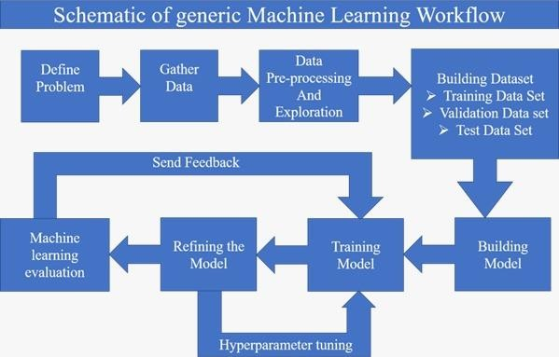

**Figure 1: Schematic of generic Machine Learning workflow**

# EXPERIMENTAL ANALYSIS

A group of persons normally living together and taking food from common kitchen constitute a household. The word 'normally' means that the temporary visitors are excluded. 'Living together' is usually given more importance than ‗sharing food from a common kitchen‘ in drawing the boundaries of a household. AC, Cooler, Washing Machine, TV, Music system, Water geyser, Room heater, Electric iron, Mixer, Vacuum cleaner, Inverter, pump motor, DVD player, Immersion heater, Laptop/ Desktop, Hairdryer, Shaver, Toaster, Microwave, Refrigerator. It is the accommodation availed of by a household for its residential purpose. It may be an entire structure or a part thereof or consisting of more than one structure. There may be cases of more than one household occupying a single structure such as those living in independent flats or sharing a single housing unit, in each case, there will be as many dwelling units as the number of households sharing the structure.

A Case Study of 343 Size of the family20: The other factor which influences the household electricity consumption is the total members in the family, i.e., the size of the family. Common perception is that, as the size of the family increases, a family would consume more electricity. But it is found that the small families (up to four members) and big families (above four members) show similar trend in ownership of the appliances. Both types of families own as less as two appliances than and as much as 20 appliances. The correlation between the size of the family and household electricity has been found positive but weak (ranging from 0.075 to 0.190) across the seasons

Stock of appliances: Generally, it is found that the whole family holds a discussion before buying any electrical appliance and more so if the appliance is expensive. The results of the present work indicate that 70.6% households disagree that buying an appliance is not a family decision.

## 4.1 PROJECT ARCHITECTURE:

The Project Architecture briefly explains the procedure involved:

* + - Firstly, Collect the dataset and split them into Training and Testing datasets.
    - Preprocess both training and testing datasets.
    - Pre-process or clean the data.
    - Analyse the pre-processed data.
    - Train the machine with pre-processed data using an appropriate machine learning algorithm.
    - Save the model and its dependencies.
    - Build a Web application using flask that integrates with the model built.
    - Open the anaconda prompt from the start menu.
    - Navigate to the folder where your app.py resides.
    - Now type ―python app.py‖ command.
    - It will show the local host where your app is running on [**http://127.0.0.1.5000/**](http://127.0.0.1.5000/)
    - Copy that local host URL and open that URL in the browser. It does navigate me to where you can view your web page.
    - Enter the values, click on the predict button and see the result/prediction on the web page.

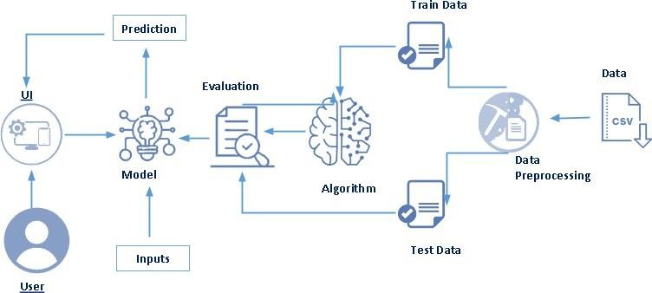

**Figure 2: Project Architecture**

## 4.2 BLOCK DIAGRAM:

Block diagram represents the procedure in systematic and sequential manner with its blocks connected by lines that show the relationship of the blocks.

* + - Initially, Labeled datasets are collected.
    - Preprocessing the data.
    - Training using machine learning algorithms.
    - Using the Linear regression models build them.
    - Classify them using linear regression.
    - Again prerprocess for selecting the dataset for prediction.
    - Finally predict them in webpage

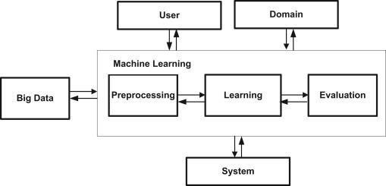

**Figure 3: Block diagram representing process of Machine learning**

## 4.3 SOFTWARE REQUIREMENTS

* Python 3.9:
  + Python is an interpreted high-level general-purpose programming language.
  + Python can be used on a server to create web applications.
* Visual Studio Code:
  + Visual studio code is a source-coeditor made by Microsoft for Windows, linux and macOS.
  + Features include support for debugging, syntax highlighting, intelligent code completion, snippets, code refactoring, and embedded Git.
* Anaconda Environment
  + The default environment base (path) is used because it consists of multiple libraries and modules.
* Pandas and numpy:
  + Pandas and numpy is used for the purpose of linear regression model building.
* Flask:
  + Flask is the module used for web framework.
  + Flask provides you with tools, libraries and technologies that allow you to build a web application.

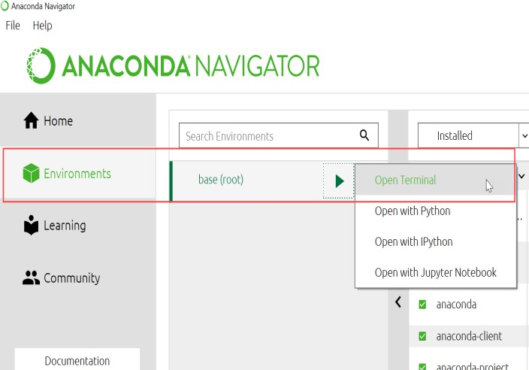

## 4.4 PROJECT FLOW

### Data Collection

* 1. In our project according to project structure, create train & test folders with 5 folders of skin diseases named Acne, Melanoma, Psoriasis, Rosacea, Vitiligo in each test and train folders.

1. **Data Preprocessing**
   1. Import dataset data generator library and configure it
   2. Apply data generator functionality to train and test datasets
   3. Import the Libraries.
   4. Importing the dataset.
   5. Checking for Null Values.
   6. Data Visualization.
   7. Taking care of Missing Data.
   8. Label encoding.
   9. One Hot Encoding.
   10. Feature Scaling.
   11. Splitting Data into Train and Test.
2. **Model Building**
   1. Training and testing the model
   2. Evaluation of Model
3. **Test the Model**
   1. Import the saved model:

Import the model that is saved in a plain text file (.h5).

* 1. Load the test data, preprocess it and then predict and check for results: Preprocessing the data and predicting the image which is required.

1. **Application Building**
   1. Build a FLASK application:

Flask provides you with tools, libraries and technologies that allow you to build a web application.

* 1. Build the HTML page and execute it:

HTML page is used for developing the webpage to display the result in webpage.

* 1. Run the app:

Run the python file such that the pages are rendered and linked to webpage‘s with a local host.

**5.DESIGN**

**UML DIAGRAMS:**

UML stands for Unified Modeling Language. UML is a standardized general purpose modeling language in the field of object-oriented software engineering. The standard is managed, and was created by, the Object Management Group. The goal is for UML to become a common language for creating models of object-oriented computer software. In its current form UML is comprised of two major components: a Meta-model and a notation. In the future, some form of method or process may also be added to; or associated with, UML.

The Unified Modeling Language is a standard language for specifying, Visualization, Constructing and documenting the artifacts of software system, as well as for business modeling and other non-software systems. The UML represents a collection of best engineering practices that have proven successful in the modeling of large and complex systems.

* + 1. Complex applications need collaboration and planning from multiple teams and hence require a clear and concise way to communicate amongst them.
    2. Businessmen do not understand code. So UML becomes essential to communicate with non-programmers essential requirements, functionalities and processes of the system.
    3. A lot of time is saved down the line when teams are able to visualize processes, user interactions and static structure of the system
  1. **5.1 USE CASE DIAGRAM**

A use case diagram is usually simple. It does not show the detail of the use cases:

* + - It only summarizes some of the relationships between use cases, actors, and systems.
    - It does not show the order in which steps are performed to achieve the goals of each use case. A use case is **a methodology used in system analysis to identify, clarify and organize system requirements** A use case document can help the

development team identify and understand where errors may occur during a transaction so they can resolve them. Every use case contains three essential elements

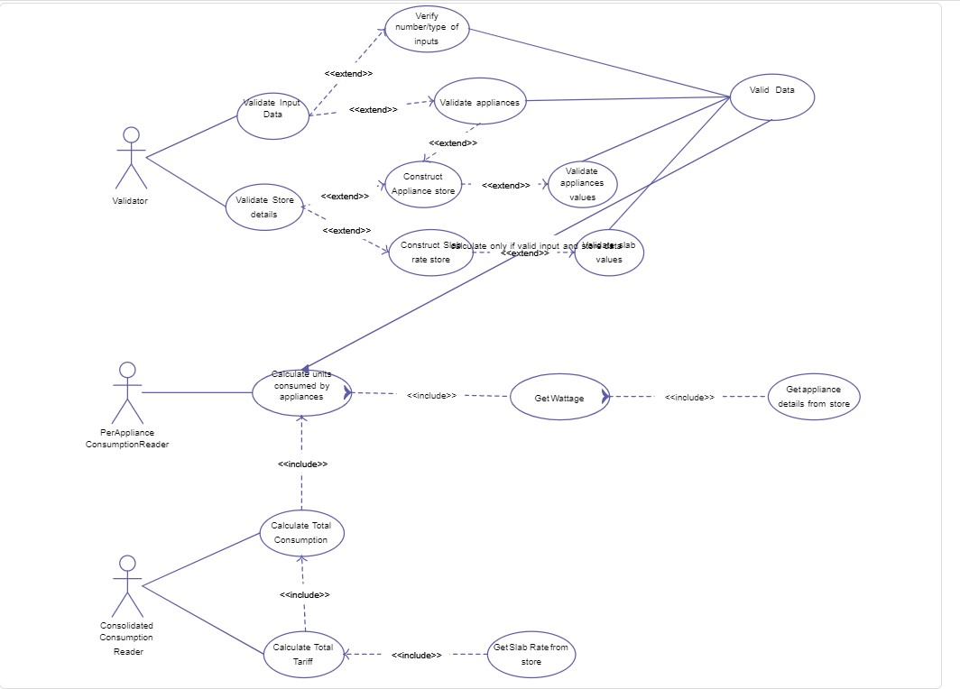

**Figure 5: Use Case Diagram**

* 1. **5.2 CLASS DIAGRAM**

Class diagram **describes the attributes and operations of a class and also the constraints imposed on the system**. The class diagrams are widely used in the modeling of object-oriented systems because they are the only UML diagrams, which can be mapped directly with object-oriented languages..

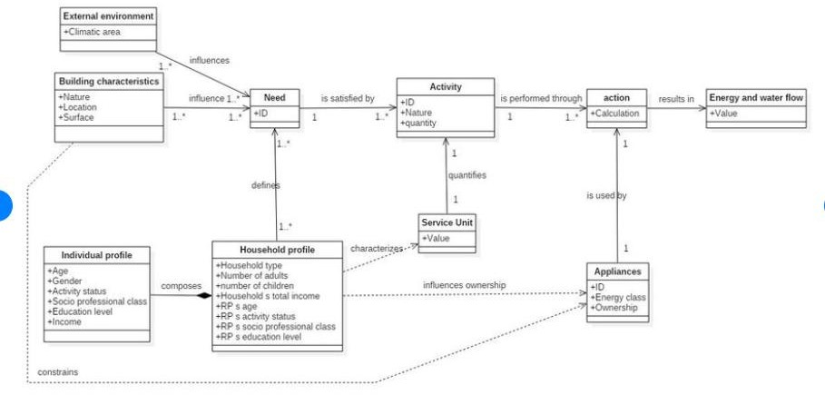

**Figure 6: CLASS Diagram**

* 1. **5.3 FLOWCHART**

A flowchart is a picture of the separate steps of a process in sequential order.

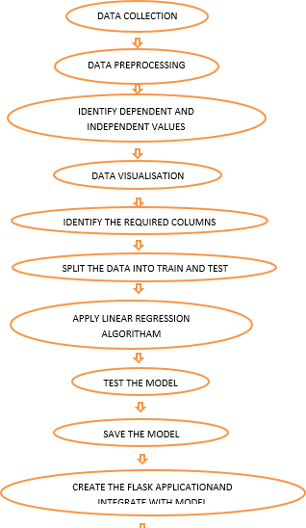

**Figure 7: Flowchart**

**6.CODE SNIPPETS**

**6.1 MODEL CODE**

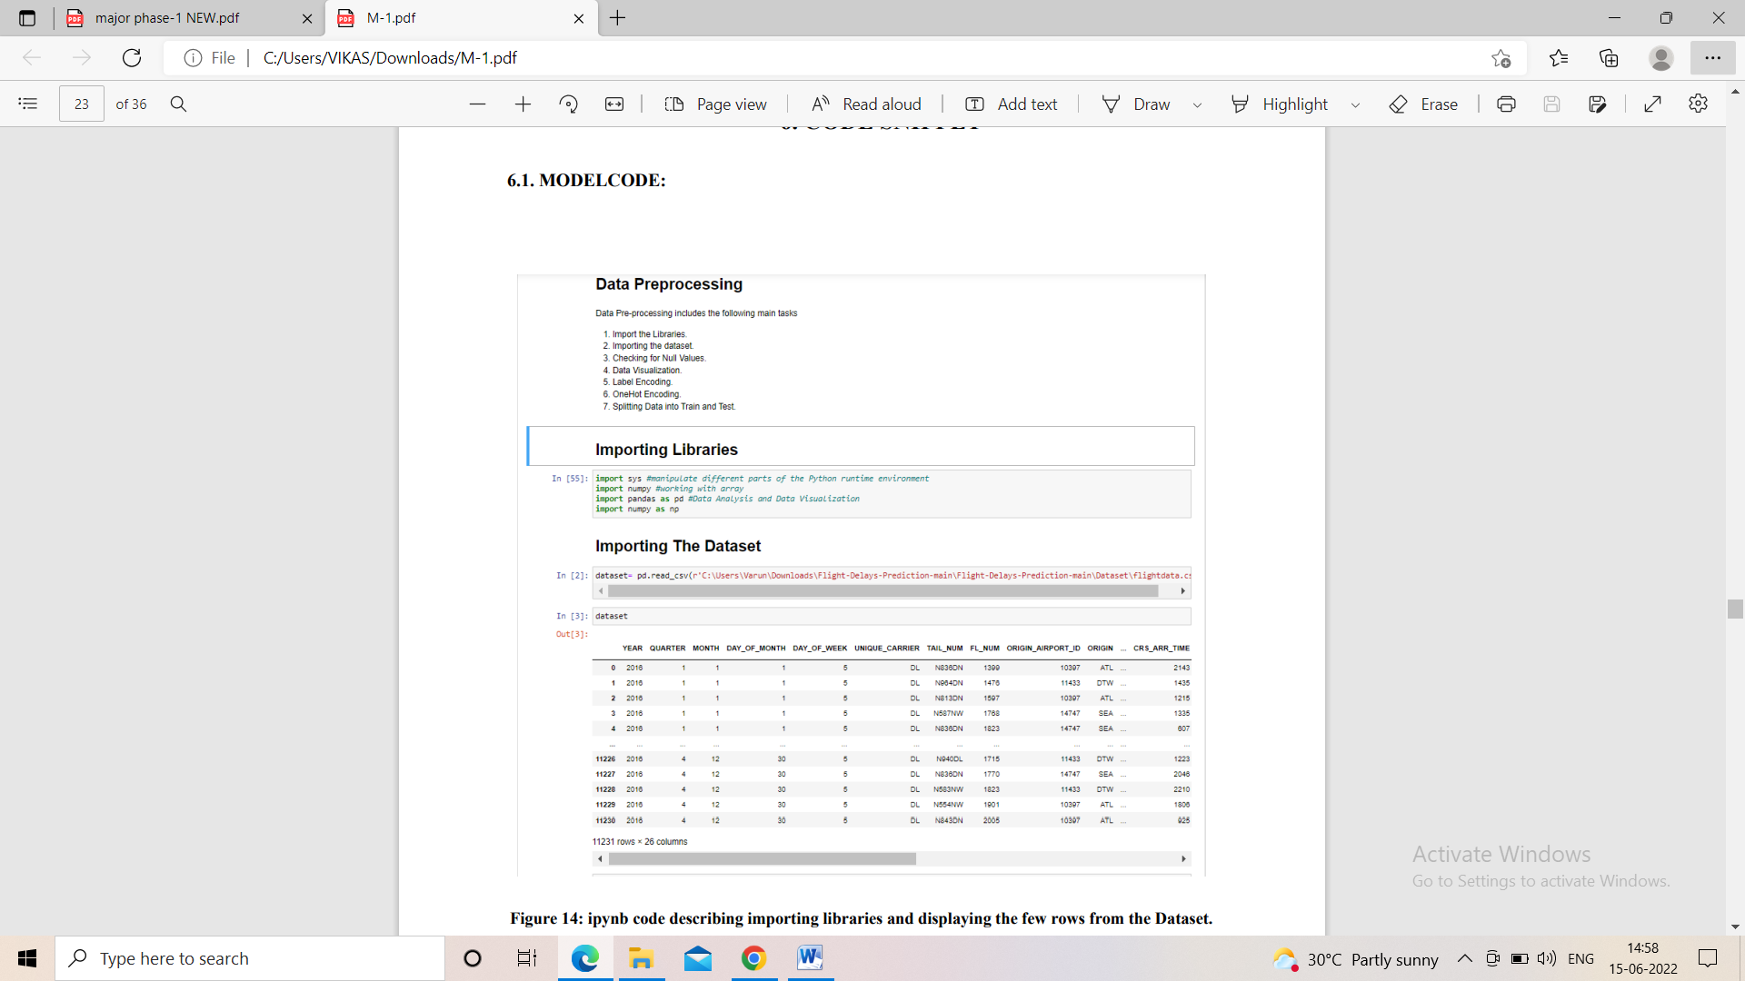

**Importing libraries and Dataset**

**Figure 8: ipynb code describing important libraries and displaying the few rows from the dataset.**

**Figure 9: ipynb code describing whether they are any NULL values in the Dataset**

**Figure10:** .**ipynb code describing filling of Null Values**.

**Figure 11**: .**ipynb code describing Area chart**.

**Figure12**: .**ipynb code describing Bar Plot**.

**Figure 13:** .**ipynb code describing Area chart**.

**Figure 14: .ipynb code describing Area chat and dataset corr**

**Figure 15: .ipynb code describing Heatmap Plot.**

**Figure 16**: .**ipynb code describing Scatter Plot.**

**Figure 17: .ipynb code describing Scatter Plot.**

**Figure 18: .ipynb code describing Scatter Plot**.

**Figure 19: .ipynb code describing Scatter Plot.**

**Figure 20: .ipynb code describing Loc, type(x) and type(y).**

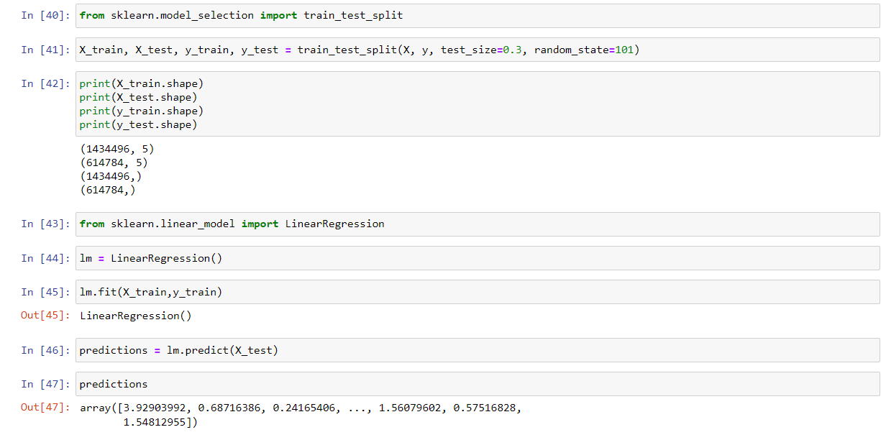

**Figure 21: .ipynb code describing label encoding and splitting the dataset into independent and the dependent variables**

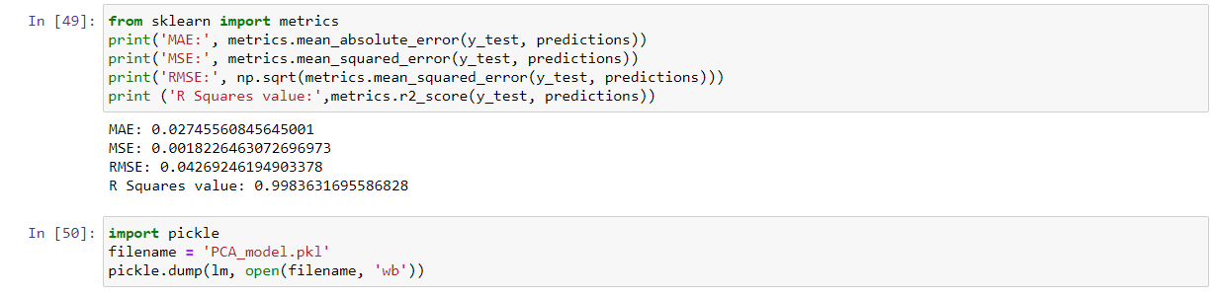

**Figure 22: .ipynb code describing finding Accuracy.**

**6.2 HTML CODE AND PYTHON CODE**

**1. App.py code:**

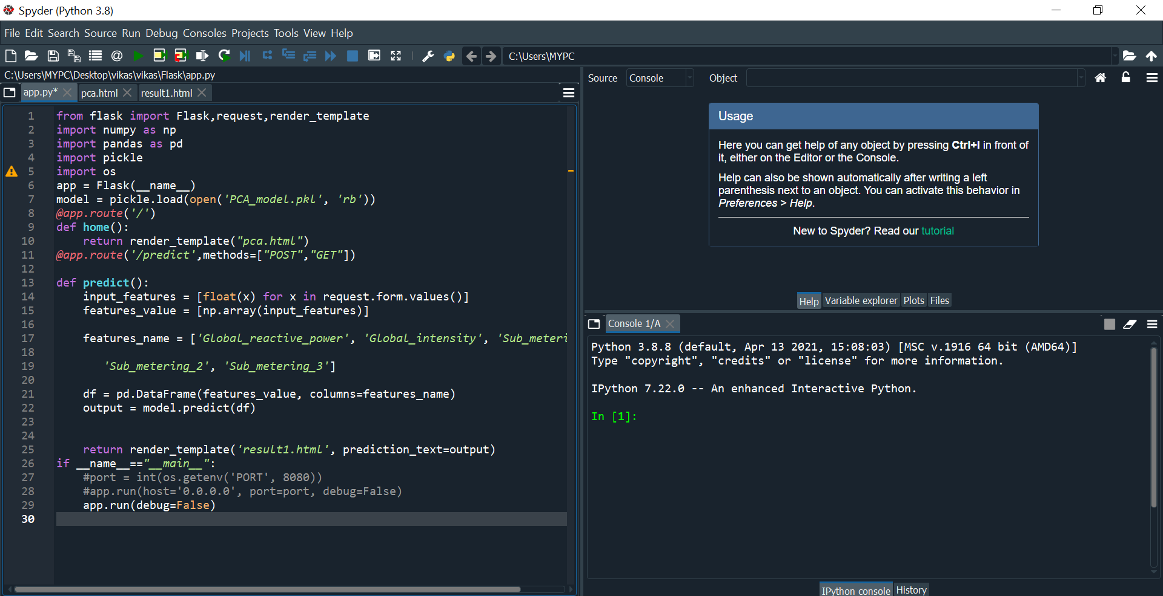

**Figure 23: Python code used for rendering all the HTML pages**.

**2.PCA.HTML**

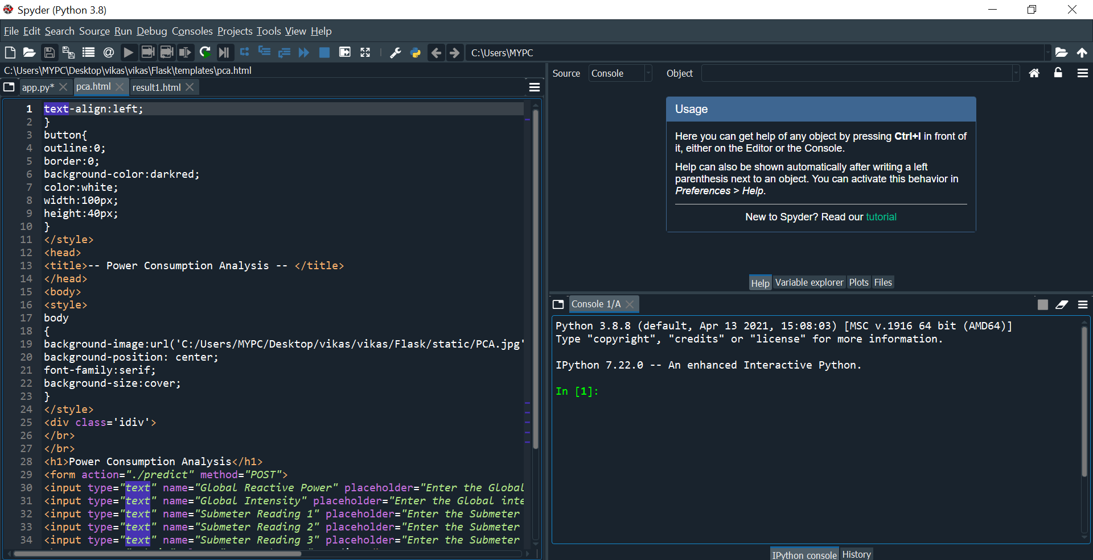

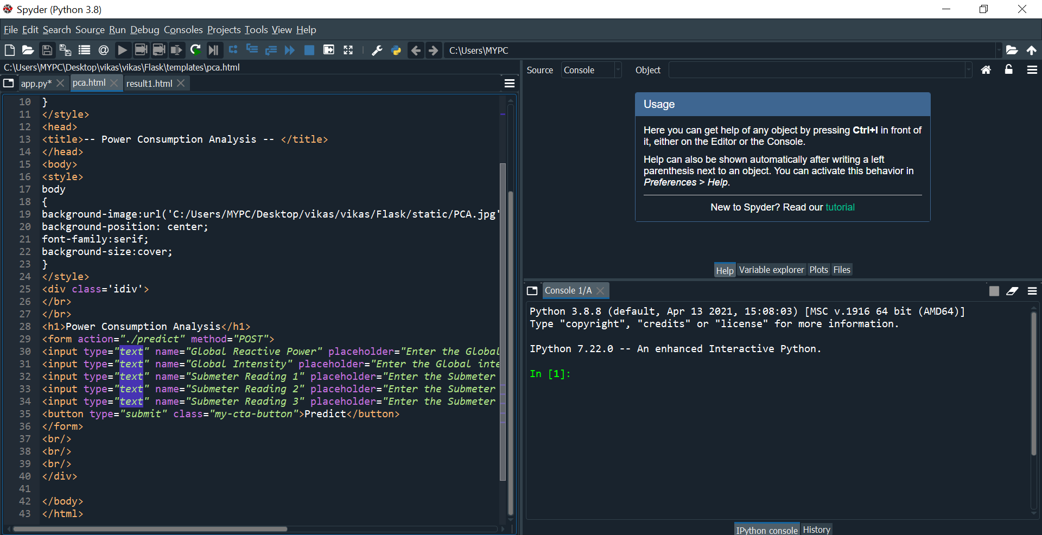

**Figure 24: Pca.html is the page that displays all the inputs that are needed to be given by the user**

**3.RESULT.HTML:**

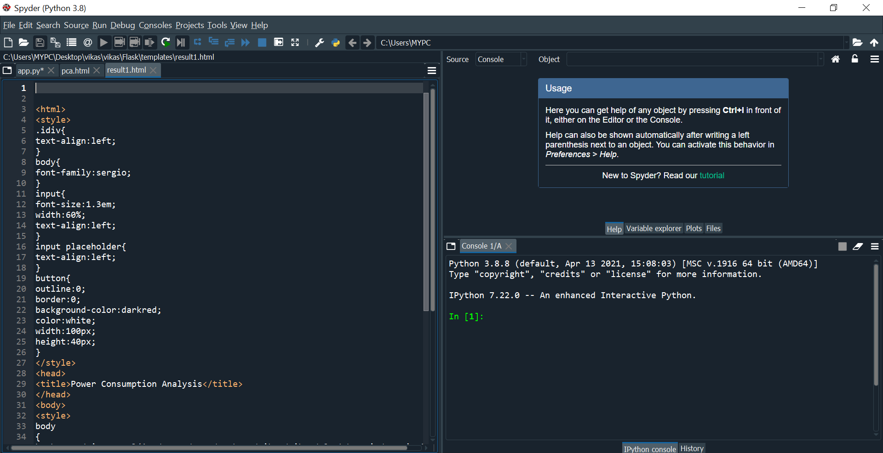

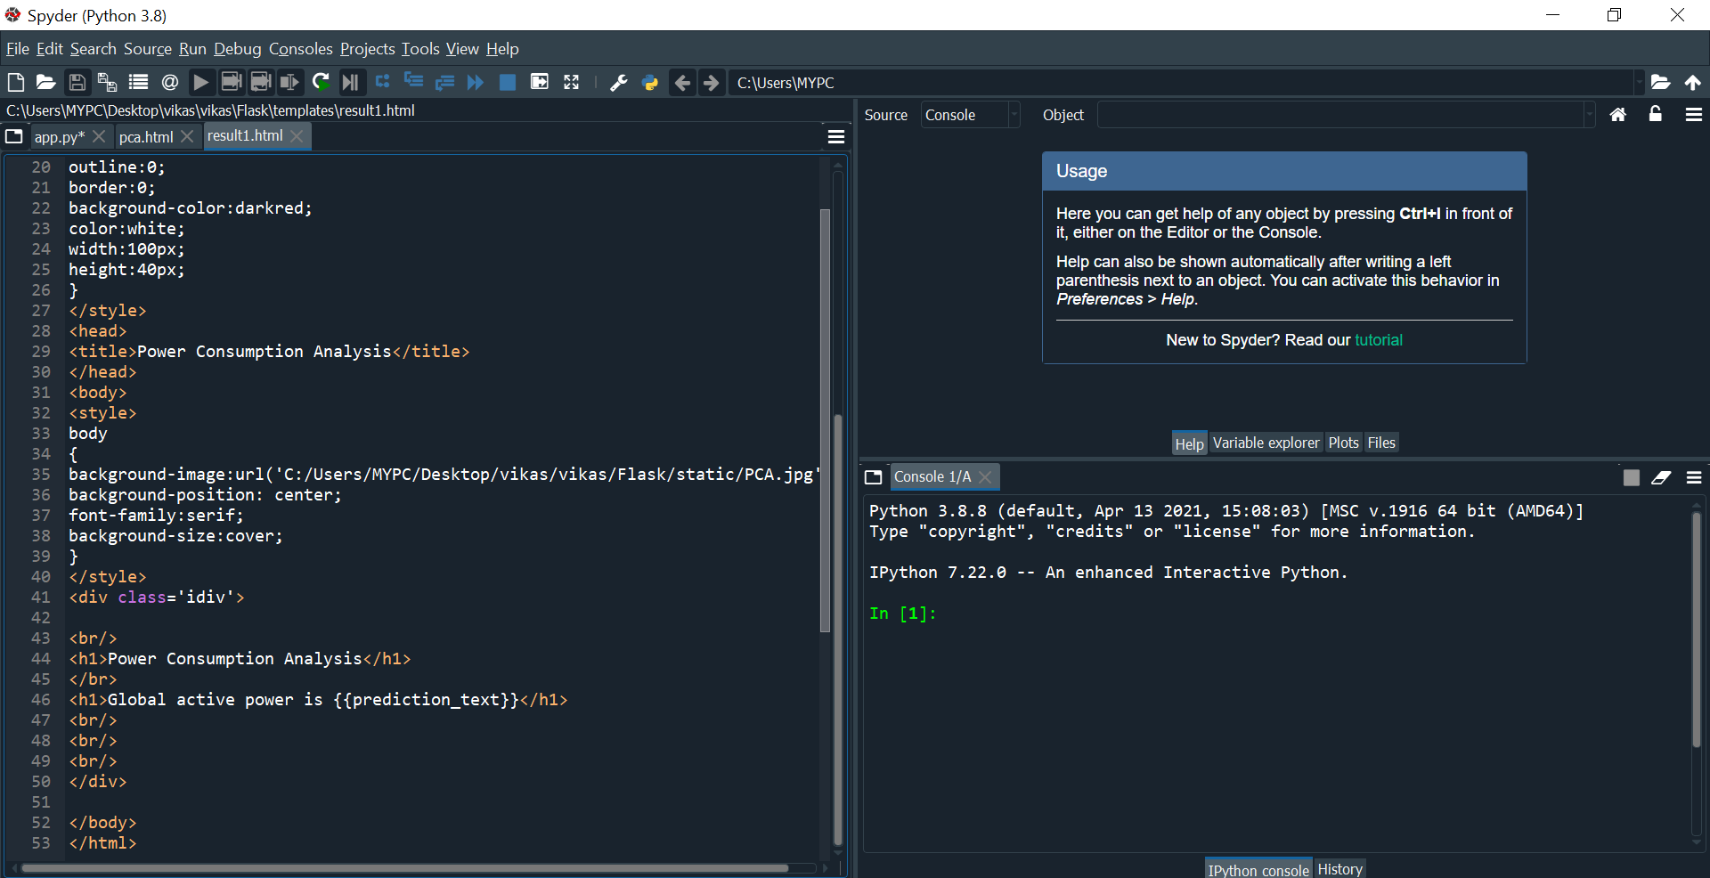

**Figure 25: Result.html is the page that displays the output.**

**7. CONCLUSION**

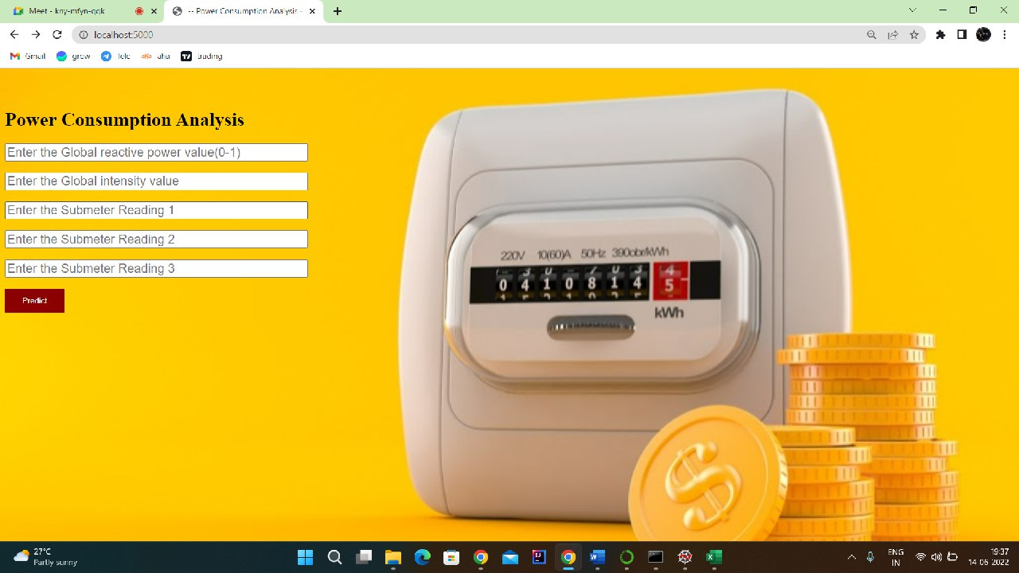

**Figure 26: Input pages (Which take the inputs from the User)**

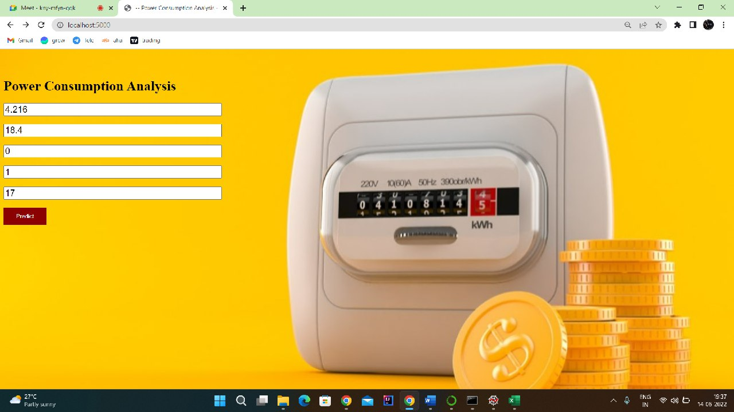

**Figure 27: Input pages (Which are given by the User)**

**:**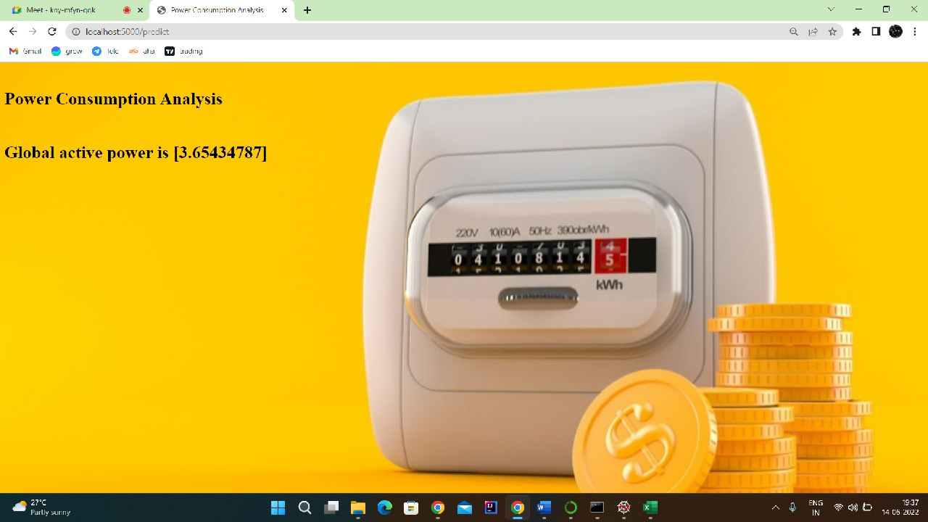

**Figure 28: Output page (Displays the power consumption)**

**8. APPLICATION**

**The areas where this solution can be applied:**

* + - Can be applied in each and every individual‘s Daily Life.
    - Can be used in current field for faster prediction in determining the power consumption.

**9. ADVANTAGES**

Monitoring power consumption of your plant provides you with the data needed to make important energy management decisions.

* + - * Understand the capacity of your existing electrical panel
      * Troubleshoot circuit breaker trips
      * Identify energy costs
      * Uncover energy waste
      * Reduces problem of disposal of organic waste
      * Renewable energy
      * Freely available
      * Clean and does not pollute the environment

**10. DISADVANTAGES**

* High cost of designing and building nuclear power station.
* Waste in the form of used fuel rods which are very hot and highly radioactive.
* Hot water discharged causes thermal pollution to the environment.
* Risk of accidents which may lead to the leakage of large amounts of radioactive substances to the environment.
* Non-renewable energy
* Discharges harmful gases that pollute the environment
* High cost
* Cost depends on political factors.

**11. CONCLUSION AND FUTURE SCOPE**

On our Dataset, we have applied Random Forest Regression and KNN algorithm, Linear Regression.

Linear Regression got the highest accuracy of 97%.

**Enhancements that can be made in the future:**

This model can be further developed to suggest what are the preventions that a power consumed with high household should be follow and Can also enhance by adding the analyzing meters which should be followed to be strong and fit. And we can further classify type of power consumed also based on the inputs given by the user.

**12.BIBLIOGRAPHY**

* + - * 1. Parminder Kaur1and Aditya Khamparia, ―Power Consumption Analysis of households", International Journal of Advances in Engineering & Technology, June, 2015,

ISSN: 22311963, Vol. 8, Issue 3, pp. 306-313

* + - * 1. Lichman, M. (2013). UCI Machine Learning Repository [[http://archive.ics.uci.edu/ml]](http://archive.ics.uci.edu/ml). Irvine, CA: University of California, School of Information and Computer Science.
        2. Bendi Venkata Ramana, Prof. M.Surendra Prasad Babu,, Prof. N. B. Venkateswarlu,‖A Critical Study of Selected Classification Algorithms for Liver Disease Diagnosis‖, International Journal of Database Management Systems (IJDMS), Vol.3, No.2, May 2011.
        3. Chuan Choong Yang, Chit Siang Soh and Vooi Voon Yap, ―A nonintrusive appliance load monitoring for efficient energy consumption based on Naive Bayes classifier‖, Sustainable Computing: Informatics and Systems 14 (2017) 34–42.
        4. Cleary, J. and L. Trigg, ―K*: An Instance-based Learner Using an Entropic Distance Measure‖, in 12th International Conference on Machine Learning. 1995. p. 108-114.
        5. Ross J. Quinlan: ―Learning with Continuous Classes‖ In Proceedings AI'92 (Adams & Sterling, Eds), 343-348, Singapore: World Scientic, 1992.
        6. Youvrajsinh Chauhan and Jignesh Vania, ―J48 Classifier Approach to Detect Characteristic of Bt Cotton base on Soil Micro Nutrient‖, International Journal of Computer Trends and Technology (IJCTT) – volume 5 number 6 –Nov 2013.
        7. S. Muthuselvan and Dr. K. Soma Sundaram, ―An Analysis of Knowledge Discovery Process Over a Cloud Environment — A Survey‖, International Journal of Applied Engineering Research ISSN 0973-4562 Volume 10, Number 17 (2015).
        8. Inderjit Kaur, Deep Mann,‖Data Mining in Cloud Computing‖, International Journal of Advanced Research in Computer Science and Software Engineering.
        9. Emmanuel Ahishakiye, Elisha Opiyo Omulo, Danison Taremwa and Ivan Niyonzima,

―Crime Prediction Using Decision Tree (J48) Classification Algorithm‖ International Journal of Computer and Information Technology (ISSN: 2279 – 0764) Volume 06 – Issue.

**13. HELP FILE**

**PROJECT EXECUTION:**

**STEP-1**: Go to Start, search and launch **ANACONDA** **NAVIGATOR**.

**STEP**-**2**: After launching of **ANACONDA** **NAVIGATOR**, launch **JUPYTER** **NOTEBOOK**.

**STEP**-**3**: Open “Major project code” **IPYNB** file.

**STEP**-**4**: Then run all the cells.

**STEP**-**5**: All the data preprocessing, training and testing, model building, accuracy of the model can be showcased.

**STEP**-**6**: And a pickle file will be generated.

**STEP**-**7**: Create a Folder named **FLASK** on the **DESKTOP**. Extract the pickle file into this Flask Folder.

**STEP**-**8**: Extract all the html files (home.html, index.html, chance.html, nochance.html) and python file(app.py) into the **FLASK** Folder.

**STEP**-**9**: Then go back to **ANACONDA** **NAVIGATOR** and the launch the **SPYDER**. **STEP**-**10**: After launching Spyder, give the path of **FLASK** **FOLDER** which you have created on the **DESKTOP**.

**STEP**-**11**: Open all the app.py and html files present in the Flask Folder.

**STEP**-**12**: After running of the app.py, open **ANACONDA** **PROMPT** and follow the below steps:

cd File Path🡪 click enter

python app.py🡪click enter (we could see running of file).

**STEP**-**13**: Then open **BROWSER**, at the URL area type “**localhost:5000**”.

**STEP**-**14**: Home page of the project will be displayed.

**STEP**-**15**: Click on “**Go** **to** **Predict**”. Directly it will be navigated to index page.

**STEP**-**16**:A index page will be displayed where the user needs to give the inputs and then click on “**Predict**”. Output will be generated “**Power consumption of Households”**..